Open file Project 🡪 eAdminLab-ejb

🡪 Server Resources 🡪 Open file: sun-resources.xml

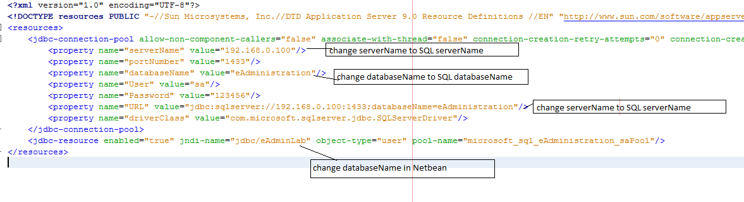C:\Users\I'mQuocAnh\Desktop\Guide_Connect_DataBase.tif

You change Name DataBase corresponding parameters